**Scope of Work:**

**Scope1: Future gate phase 2:**

**The below are the requirements:**

|  |  |  |  |  |  |  |  |  |  |  |  |  |  |  |  |  |  |  |
| --- | --- | --- | --- | --- | --- | --- | --- | --- | --- | --- | --- | --- | --- | --- | --- | --- | --- | --- |
| |  |  | | --- | --- | | **Requirements regarding the design of the "future gate" interface** | Any requirements regarding the position of the contents will be under the responsibility of the vendor UI/UX team | | **Sending "success story" screen (by users)** | This screen allows users to send a success story, which will be shown on the respective dashboard (for approval or rejection) before got published for public | | **"Future gate" control panel (Backend)** | To add/ update/ delete the home page banner | | Survey & Questioners control panel:  This screen allows the user who has the authority/ permission to manage (add - delete - update) questionnaires and surveys where the questionnaire/ survey's questions, activation date, hidden date will be controlled and the type of questions that are entered (multiple choice question "One answer", multiple choice question "multiple answers", questions with free Text answer) will be defined while creation. A screen of reports to show the results of the questioners and surveys with a graphical presentation (drawings, charts, statistics, etc..) with the possibility of extracting reports in Excel & PDF format. | | Success Stories Control Panel: This screen allows the authorized user to create a "success story" or handle success stories sent by future gate users via a predefined workflow for approval or rejection. The system sends alerts to each event (success story creation- take action on application, etc ...) The content of the story that has been created is text, video, images and dates.  The system administrator can also add a success story. | | Ad management screen: This screen allows the user to (add, edit, delete) an ad so that the ad appears when added to the future gate's home page. The ad contains the following types of data (text - image - start and end date, creation date, link) Type of questionnaire: general or require a login. | | **Technical support through Live chat** | Propose a live chat solution after conducting a detailed study on the available solutions for technical support through Live chat on the website  Some of the features expected: • Manage agents from the control panel • Reports on the conversations, such as average response to users, fastest or slowest response time, and number of conversations done by the agent ... • Keep the history of conversations. | | **Academic Calendar** | Link with the Ministry of Education calendar and display it in the main portal (Home page). RSS link with calendar | | **Future gate EVENTS** | Add a Module for "Future gate" events with its own time schedules. The events include a date, text, picture or group of photos and administrator.  Implement mechanism to display the Important and the coming (Closest) events with possibility of displaying all events on the Control panel screen (Dashboard) | | **Useful links section** | A section to the main portal contains the following: - Links to important sites. - Mobile App Links. | |  |
|  |  |

**Scope2: The proposed portal for the Future Gate Award for Excellence**

**The proposed portal for the Future Gate Award for Excellence**

This document contains a detailed and integrated proposal for the process of automating the application process for the “Future Gate Award for excellence” and the evaluation/ judgment process of the electronic monitoring system by converting all the system processes to be electronic starting from designing the submission forms by the supervisors and then simplifying the application process for the candidates as well as assisting supervisors and judgers in performing their tasks.

**The system used for the portal**

It is important that the system starts from designing and submitting the forms to the announcement of the results electronically in such a way that it is easy for the supervisors to design and upload the forms and sorting the submitted applications, as well as it should support the candidates in the application process, as well as evaluators in the evaluation and marks capturing process in an easy and sequential manner.

Therefore, it is requested to build the system to manage the following four stages:

1. **Forms Design phase**

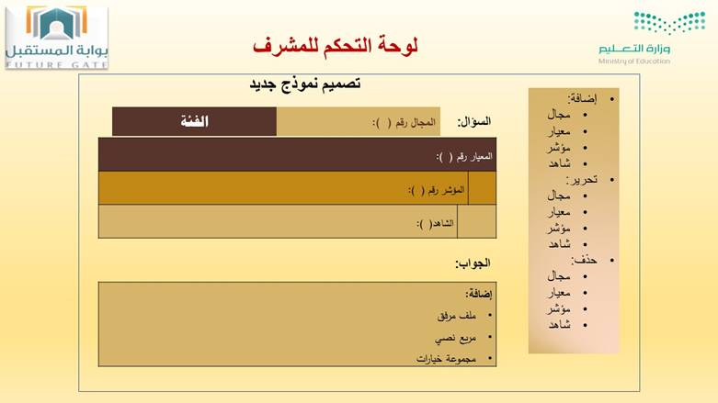Before the start of the competition, the portal administrators will design the contents of the forms of each category and enter the indicators, criteria, proofs in a simplified and sequential manner. And then publish it on the site. As shown in Figure 1.

**Answer:**

**Add:**

* File attachment
* Text Box
* Multiple choices

Proof # ():

Indicator # ()

Criteria # ():

Category:

Domain:

Question:

**Admin control panel**

**New Form Design**

Add:

* Domain
* Criteria
* Indicator
* Proof

Edit:

* Range
* Criteria
* Indicator
* Proof

Delete:

* Range
* Criteria
* Indicator
* Proof

*Figure 1: Simplified system model showing the interface and contents of the admin page*

1. **The candidates submission process**

The candidate fills out the submission page form where participants can choose their form via the website after opening an account (Sign up) using the national ID or mobile number.

After that, the candidate can answer all questions of his form directly on the system so that the system displays all the required proofs/ evidences, and next to each proof an icon to load the proof / evidence image. It also shows a confirmation mark for uploaded files so that the form can only be submitted after all the evidences are confirmed (Uploaded) and the file are completed. As shown in Figure 2.

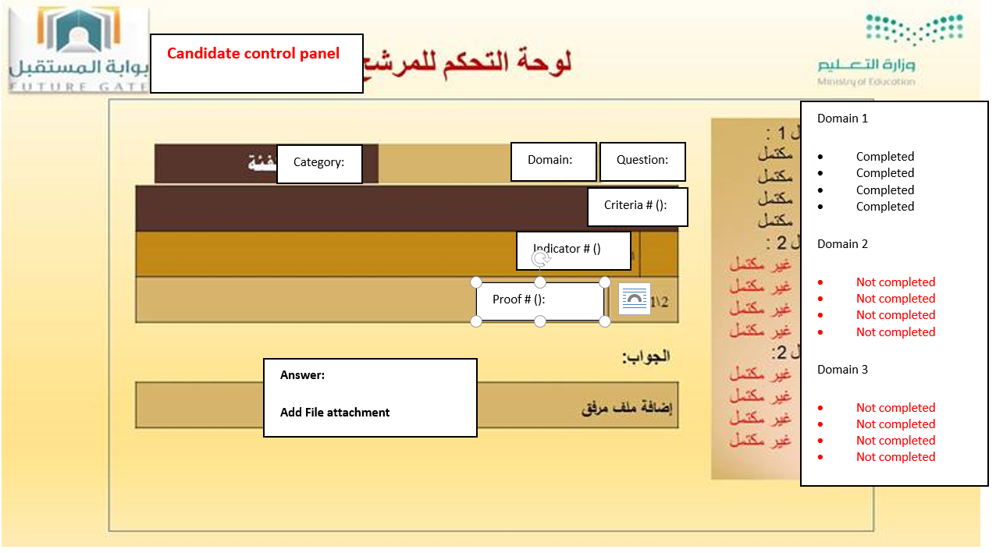

*Figure 2: Simplified system model showing the interface and contents of the candidate's page*

1. **Sorting and review by supervisors**

At this stage and after the completion of the candidate applications submission process, the qualified applications will be sorted automatically and the uncompleted applications will be excluded. Administrators can also review the uploaded files and ensure that they are completed and exclude all the applications which are not matching the pre-defined conditions with the help of the system.

Then the supervisors of the competition will distribute these applications among to the evaluators where there is an account for each evaluator and supervisor with different authority and permissions.

So, the system helps the supervisors in distributing the participant applications among the evaluators, and helps the evaluators in evaluating the applications and give them marks using some mathematical equations previously entered by the supervisors.

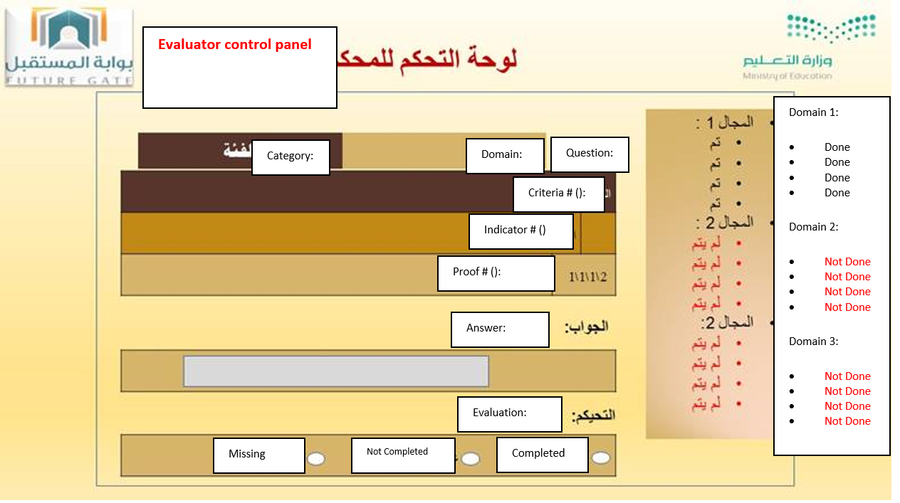

*Figure 3: Simplified system model showing the interface and contents of the Evaluator page*

1. **Evaluation Stage**

At this stage, the system displays for the evaluator all the evidences enclosed under each indicator as the candidate submitted, so that he evaluates the proof/ evidence and give a mark/ score directly on one page without having to move between files and other systems. As shown in Figure 3.

The system then allows administrators to view and print the final automated report of the evaluation.

**Technical characteristics of the portal**

* It is important that all the systems used in the portal are designed using the latest technologies used in the field of programming, namely Microsoft ASP.NET, one of the most popular site development tools and databases in the market, and there are a very large number of programmers who work efficiently on These tools are supported by highly efficient companies and have continued support and development.
* The portal uses the latest technologies in database management, namely Microsoft SQL Server or similar.
* All operations on the system will be executed in full electronic forms.
* The control panels and dashboards in the portal are comprehensive using it, admin users can modify the contents of the portal and control the permissions of the users and control the constants in the system to operate efficiently.
* The system makes backup copies of the portal periodically during the award cycle, in addition to a comprehensive backup of the database and source code at the end of the period, as well as all data uploaded through the system during the period of the award. When starting a new award cycle, the system migrates all the previous data into an archive within the database with access to this data through the system permanently, and all the files uploaded to the system and stored in storage systems outside the host.
* The portal domain and hosting through a site within KSA, and that all private servers exist within KSA. Hosting size exceeds 200 gigabytes by private server. These servers are fast and high-capacity to enable candidates to upload files directly to the system.
* The portal provides all the services and processes that can be done through the system to include all services that support the requirements of teams working in the award.
* The vendor includes the annual maintenance of the portal by preparing it to work at the beginning of the award cycle, preparing the constants in the system, managing the user data of the system, and entering some data related to the award. The system components can be modified as needed and rapid solutions are implemented in the event of errors in system.
* The vendor should provide comprehensive documentation that covers all services offered by the system and way it was designed with a detailed explanation of all the operations in the system and clarify the link of these processes with users of the systems to be a reference document for all employees on these systems and anyone who wants Know the details of these systems or develop them in the future.
* The system should be able to issue all reports at the end of the award cycle to keep them in the form of files that can be referenced permanently without reference to the systems in order to achieve greater security when any problem occurs in the systems.
* The security of the systems is very high, and the security tests are carried out continuously and permanently
* The general appearance of the systems is determined by using the latest international designs.

**Conclusion:**

Through the previous explanation of all services of the desired system, you can note that the objective is to transfer all services and processes related to the award to be electronic in a comprehensive and simplified way through serial and connected pages for each process required (state of art UI/UX). By using the portal, the number of employees of the award will be reduced and that will save money and also reduce the time period of the award, which can be completed using the system in a few weeks from the beginning to the announcement of the results.

**Detailed Technical Specifications**

**Below are details of Technical Specifications**

**First: Work Requirements**

**Schedule of Charges**

**Schedule of Charges**

|  |  |  |  |
| --- | --- | --- | --- |
| Schedule of Charges | | | |
| S | **Item** | **Price (In numbers)** | **Price (In Writing)** |
|  |  |  |  |
|  |  |  |  |
|  |  |  |  |
|  |  |  |  |
|  |  |  |  |
|  |  |  |  |
|  |  |  |  |
|  |  |  |  |
|  |  |  |  |
|  |  |  |  |
|  |  |  |  |

5-Attachments

5.1 Bid Letter:

The bidder will write the following on his official papers:

M/S Tatweer Educational Technologies Co.

Greetings,

After reviewing the tender papers and all related documents, items of technical specifications and quantities, and having obtained all necessary information related to the tender, we, the undersigned, bid to carry out the terms specified in the tender documents, under the provisions specified therein for a total amount of:

|  |  |
| --- | --- |
| Bid Value (In Numbers) | Bid Value (In Writing) |
|  |  |

We guarantee that our bid is in in full conformity with the general and specific instructions of the bidders and that it conforms to the terms and conditions of the draft contract without exception, distortion or modification.

We attach with this bid an bid bond of (%) of the total value of the tender issued by ………….. Bank and still valid until. / / 14 AH.

We also agree to adhere to by this tender for a period of 90 days from the date set for opening envelopes. If our bid is accepted, we pledge to provide a performance bond equal to (5%) of the total value of the contract.

In the event of acceptance of our bid, we shall sign the contract immediately upon serving a notice to you and make all necessary preparations to start implementation immediately after receipt of the sites and undertake to complete the work until the end of the project term.

Bidder name.................................................................................

Authorized Representative Name.................................................................................

Authorized Representative signature.................................................................................

Date...............................................................

**Answer:**

**Add:**

* File attachment
* Text Box
* Multiple choices

Proof # ():

Indicator # ()

Criteria # ():

Category:

Question:

Domain: